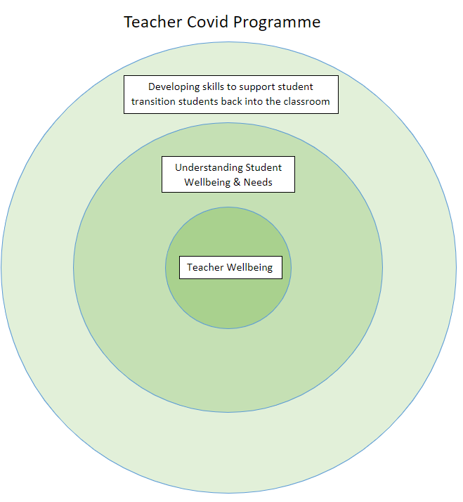
Sessions
Teacher Wellbeing | Understanding Student Wellbeing and Needs
- Mental Health and Wellbeing for Teachers  - Mentoring  - Planning workload  - Digital skills to help with wellbeing and workload | - Understanding and supporting individuals’ needs in your teaching plan  - Trauma-informed practice resources  - Behaviour management resources  - Managing difficult behaviours resources  - Neurodiversity resources
Developing skills to support student transition back into the classroom
- Supporting learners with low literacy skills resources
- Supporting learners with low numeracy skills
- Setting and maintaining high expectations resources
- Classroom culture resources
- Cognitive Load Theory
- Digital skills to support online teaching

Outline of Programme
Teacher Wellbeing
The teacher Covid Response programme focuses on teacher wellbeing at the heart of the programme, as the pandemic has impacted everyone. It provides the foundation to support teacher wellbeing and is delivered in short, targeted sessions to support teachers and give them strategies to use in their everyday roles.
Understanding student wellbeing and needs
The impact of the pandemic has led to a rise in mental health wellbeing issues amongst learners, leading to a need to equip teachers with the skills to support students’ transition back into the classroom. In FE, teachers have a diverse range of learners within their classes. New and inexperienced teachers need the tools and knowledge to adapt their teaching to meet all learners’ needs.
Developing skills to support student transition back into the classroom
The impact of the pandemic has left students with gaps in their knowledge and struggling with the core skills that are essential for learning. Developing new and inexperienced teachers’ knowledge about cognitive load theory and how to embed and develop Maths, English and digital skills will accelerate progress in the classroom, allowing them to catch up on missed learning. It is important to continue to develop teachers’ digital skills for the enhancement of resources for both in-class and online teaching.

