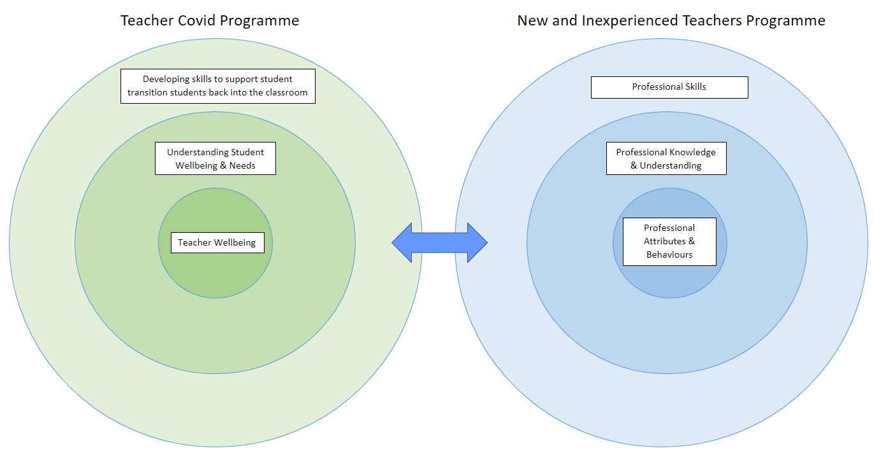
Year 1:
Delivery of the programme will be blended learning with some sessions delivered face to face whereas other sessions will be online or asynchronous. Sessions will have reflection points and questions that will be used to promote discussions and teacher development in mentor meetings. At the start of each term mentors and mentees should review the mentee’s development journey as a teacher to identify the areas of focus for that term and identify key sessions to attend (this should be revisited in mentor sessions throughout the term and adapted if needed).
Term 1 Overview
The first block focuses on developing and establishing your classroom culture. The block will help you to understand the core systems and skills used in everyday teaching practice in your organisation. In the second half of the block, you will focus on how learners learn with an emphasis on the role of memory.
Theme Area | Sessions | Other Training Activities
Core organisation skills and systems and introduction to teaching for new and unqualified teachers | - Digital skills – PPt, Word, Google etc  - Safeguarding and Prevent  - GDPR  - Registers and student data  - Reporting safeguarding concerns  - Learning platforms  - Progress reviews on student and personal  - Teaching essentials | Bespoke training on systems used in the organisation for teaching.  Exam board specific training – marking/access
Establishing a positive climate for learning and effective classroom management | - Understanding the foundations of establishing a positive climate for learning  - Setting and maintaining high expectations  - Classroom culture  - Behaviour management  - Managing difficult behaviours  - Trauma Informed practice  - Developing your positive and safe learning environment for the first term  - Understanding reflective practice  - First block reflections | Level 2 Safeguarding  Prevent Training  Meetings with Mentor
How students learn: Memory & Cognition | - Understanding how learners learn through evidence-based practice and an introduction to cognitive load theory  - Understanding cognitive load for teachers and its implications  - Presenting new content and skills  - Identifying and preventing misconceptions  - Developing strategies to teach more complex concepts and skills  - Developing teaching and learning approaches in practice to avoid cognitive overload.  - Second block reflections | Workplace learning philosophy  Workplace learning cycle for learning  Subject-specific workshops/working groups  Meetings with Mentor
Term 2 Overview
In the second term, you explore what makes effective teaching via developing your understanding of curriculum and pedagogy. The areas you will explore will be effective planning, developing subject knowledge and curriculum development.
Delivery Block | Sessions | Other Training/Activities
Developing effective classroom practice: teaching and adapting | - Exploring through evidence practice what makes an effective teacher  - Understanding planning for learning through developing lesson planning  - Developing teaching practice through skills, practical sessions and modelling  - Understanding and supporting individual needs in your teaching and planning  - Developing an understanding of neurodiversity  - Using assistive technology  - Third block reflections | Revisiting the organisation learning cycle for learning  Bespoke training from SEND department on specific SEND  Peer observations  Observations of expert practitioners  Subject-specific workshops/working groups  Meetings with Mentor
Developing subject /skills and curriculum knowledge | - Understanding the role of developing subject knowledge for effective teaching and planning  - Exploring the underpinning elements of curriculum design - Including Ofsted’s 3Is (intent, implementation and impact).  - How to complete a scheme of learning  - Understanding the importance of developing and embedding literacy in curriculum design  - Understanding the importance of developing and embedding Maths in curriculum design  - Fourth block reflections | A series of subject-specific workshops  Exam board specific training – marking/access  Meetings with Mentor
Term 3 Overview
In this term, you will explore and develop your understanding and approaches to effective assessment. You look at how you can use assessment and feedback can be used effectively to inform planning and support learners in making progress. You will reflect on the professional relationships you have grown this term and explore the importance of developing professional relationships with key stakeholders.
Assessment Feedback and Questioning | - Teaching for mastery  - Understanding what makes effective assessment and feedback  - Understanding the role of assessment in education and how is it used to inform planning  - Exploring and developing different assessment strategies and how to use them in the classroom to move students on in their learning.  - Stretch and challenge to develop personalised learning  - Developing group marking formative assessment  - Developing effecting questioning strategies for more impactful teaching  - Using student data for planning classroom delivery  - Fifth block reflections | Exam board specific training – marking/access
Professionalism and Reflective Practice | - Building positive effective relationships and communication in the workplace  - Understanding Equality and Diversity  - Building positive effective relationships with students, parents, and carers  - Building relationships with supportive adults in the classroom and developing them effectively to support students.  - Understanding the different roles in education and external agencies  - Role of a SENCO in a college and supporting learners working with a TA  - Sixth block reflections | Talks from different people with different roles in the organisation
Year 2:
Year 2 of the induction programme will go more depth into developing the themed areas of the Year 1 of the induction programme (Please see the examples below)
Developing effective classroom practice: teaching and adapting | Meeting students’ needs for specific SEND: Dyslexia and ASD
Developing subject /skills and curriculum knowledge | Decolonising the curriculum

