Session 3: Classroom-based teaching TOOLKIT for trainees with little classroom experience

* The Learning Cycle
* Flipped Learning
* Assessment for Learning
* Feedback

Explore the Learning Cycle

](https://activatelearning.sharepoint.com/:p:/r/sites/FEDGP/Shared%20Documents/Workstream%203/Resources%20to%20be%20shared%20to%20DfE/Learning%20cycle%20explored.pptx?d=wf67391a671ad4d63b5b19add87e3ecc9&csf=1&web=1&e=aGbdGN)

 CASE STUDY ACTIVITY

Pick one of your classes and create a lesson plan. Plan a lesson using the Learning Cycle.

|  |
| --- |
| **Connect and Check** |
|  |

|  |
| --- |
| **Share** |
|  |

|  |
| --- |
| **Present** |
|  |

|  |
| --- |
| **Apply** |
|  |

|  |
| --- |
| **Recall and Review** |
|  |

Flipped classroom

](https://activatelearning.sharepoint.com/:b:/r/sites/FEDGP/Shared%20Documents/Workstream%203/Resources%20to%20be%20shared%20to%20DfE/Resource%203%20-%20Classroom%20based%20teaching%20for%20trainees%20with%20little%20classroom%20experience/Resource%203%20PowerPoint%202%20-%20Flipped%20Learning%20session%20tasks%20.pdf?csf=1&web=1&e=PNeHJw)

ACTIVITY - Carry out PRE-SESSION RESEARCH task on Flipped and complete Tasks 1 and 2. Once you have completed tasks 1 and 2 Plan a flipped learning lesson for one of your classes.

* **Pre-session task:** How would you set it up? Would all students have the same task, or would they work in groups? How would you ensure all students completed their pre-session task?
* **Lesson Session:** What would you do if some students haven’t completed their pre-session task?
* **Plenary:** What activity can you use to enable students to reflect on their learning so far?

Assessment For Learning (AFL)

](https://activatelearning.sharepoint.com/:p:/r/sites/FEDGP/Shared%20Documents/Workstream%203/Resources%20to%20be%20shared%20to%20DfE/AFL.pptx?d=w38d995a598d64ad79be865b0949b25de&csf=1&web=1&e=eh5BQy)

ACTIVITY - Explore the Rosenshine Principles of instruction (Click the picture)

[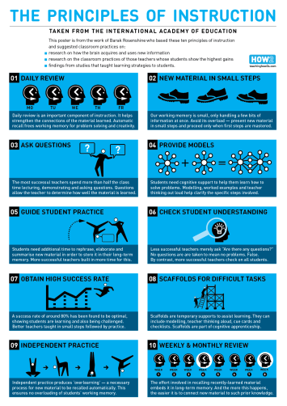](https://www.aft.org/sites/default/files/periodicals/Rosenshine.pdf)

* Reflect on how this principle might be used to elicit evidence of student learning
* What strategies/activities are you using that are linked to the principles?

ACTIVITY – Reflect on how you are going to develop Assessment for Learning over the year

feedback

](https://activatelearning.sharepoint.com/:p:/r/sites/FEDGP/Shared%20Documents/Workstream%203/Resources%20to%20be%20shared%20to%20DfE/Feedback.pptx?d=wcf51e2e8ded742779612fbf426d61efe&csf=1&web=1&e=RthgFr)

ACTIVITY

Reflect on some recent feedback you have given to a learner. How could you have improved that feedback?

 MENTOR MEETING ACTIVITY

In your mentor meeting discuss the learning you have taken away from the classroom-based teaching for trainees with little classroom teaching. **The mentor activities might be over a series of sessions.**

* Reflect and discuss with your mentor a lesson plan which you have created with the learning cycle
* Discuss with your mentor how you have planned to develop ALF in your next lesson
* Discuss your reflections on the student feedback you received and how you would develop it further
* What tool/task could you use to find out how effective the flipped session you planned was?

Following this discussion, record any actions/areas for development.