# Session 4: Understanding and supporting individuals needs in your planning and teaching.

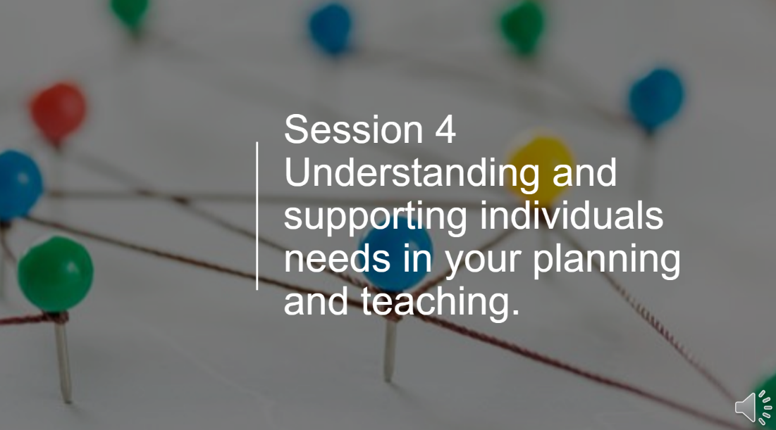

#### Case study activity

#### Following the enrolment of learners on your course, you have been given a group overview with the following needs identified:

*Group Profile for Level 3 Animal Management*

|  |  |
| --- | --- |
| *Learner Initials* | *Individual need* |
| *JK* | *Hearing impairment* |
| *SJ* | *English as a Second Language (recently moved to UK). Spoken language is Shona* |
| *AW* | *Emotional Behaviour Issues* |
| *WM* | *Generalised anxiety disorder (regular panic attacks)* |
| *CC* | *Caring responsibilities* |
| *AW* | *Young parent of twins* |
| *HS* | *Dyslexia and motor ticks* |

### Explain how you would support the individual needs in your planning and teaching

|  |
| --- |
| **Planning** |
|  |

|  |
| --- |
| **Teaching** |
|  |

## Individual learning plans

](https://activatelearning.sharepoint.com/:p:/s/FEDGP/EfxmrAh8jRhJm2LJD1OvIR8BQwNDmnduDFezGlaWTvMkfA?e=3B898N)

### Activity

### Pick one of the learners above and write an individual learner plan. You could use the format or template used in your department.

# Mentor Meeting Activity

In your mentor meeting discuss how to support learners who have additional needs. Bring an ILP or Learning Support Plan for one of your current learners to your meeting. Discuss the current support which you are providing for this learner and reflect on the following

* How you plan to meet their needs effectively in the classroom?
* If the learner has LSA Support, how does this work in the classroom? How do you plan for additional adults?

Following this discussion, record any actions/areas for development.